Availability slots & Booking consultations
Updated at : 07/06/2024

1. Availability slots
1.1 Availability slot setting
Doctors can set their availability slots in the doctor's panel. Settings can be categorized into three types:

1.1.1 General settings: For relatively fixed work schedules, settings are based on the days of the week to avoid setting them every day.
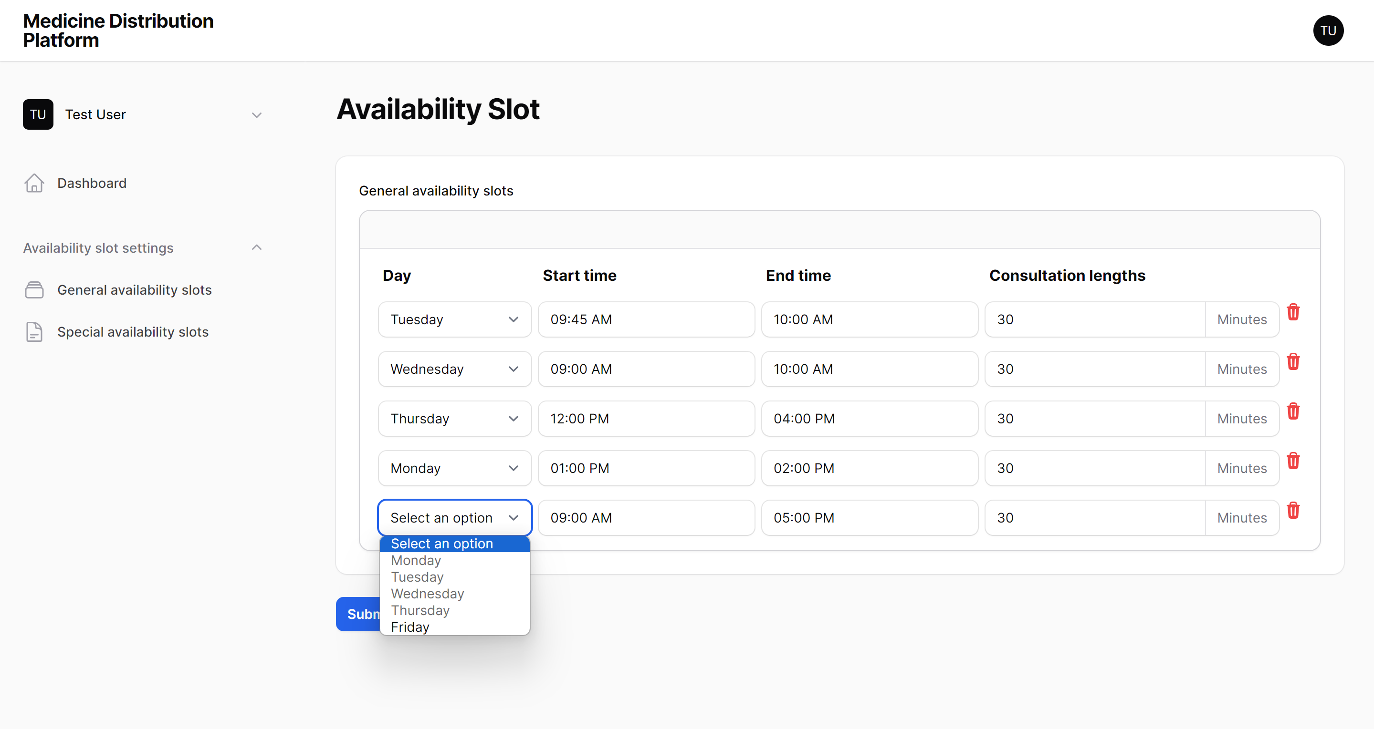

1.1.2 Special settings: Based on the general scheduling, adjustments can be made for special circumstances.
- Full-day leave, such as sick leave, where one or more days need to be taken off.
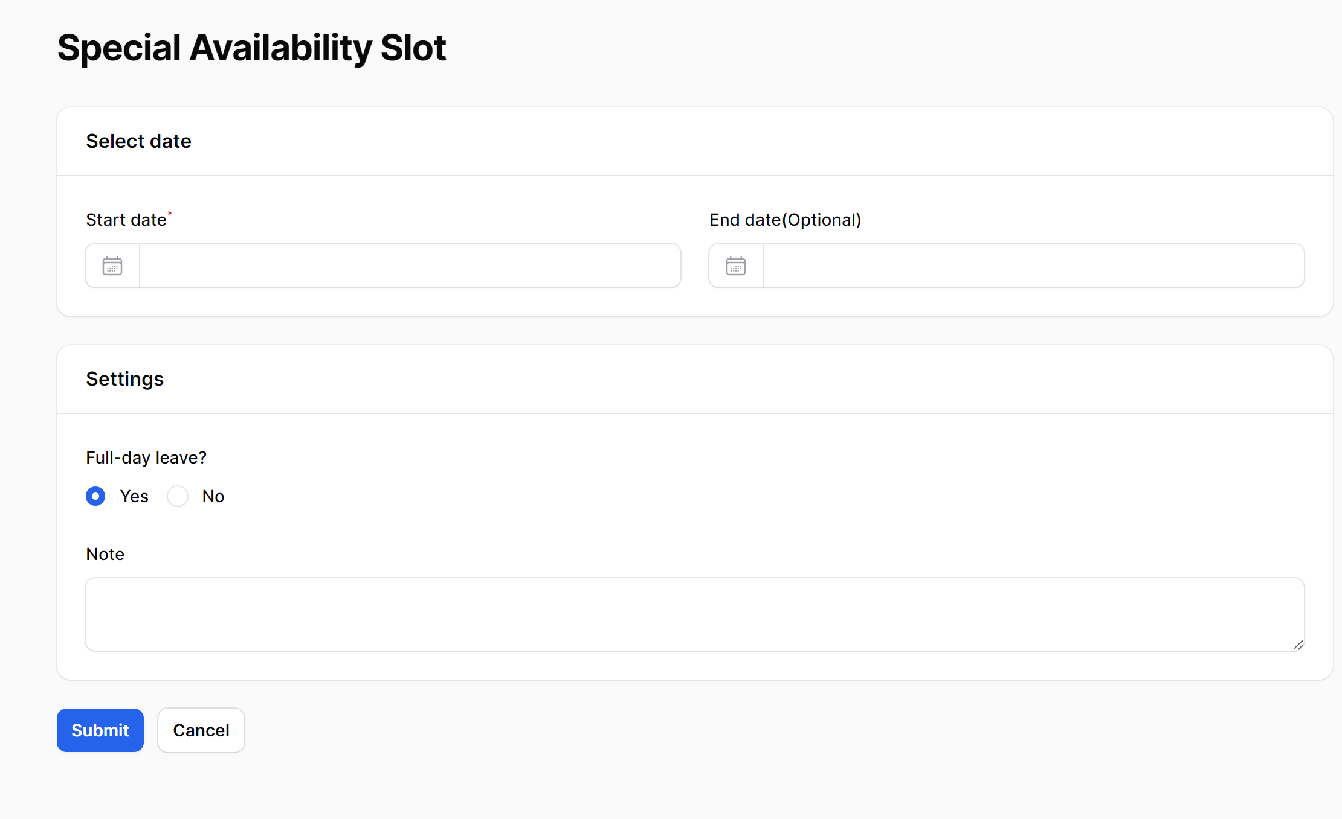
- Temporary changes to the original plan in the general settings, such as leaving early on a specific day. For example, if a day is set as 9:00-17:00 in the general settings, but on that day, the schedule needs to change to 9:00-12:00.
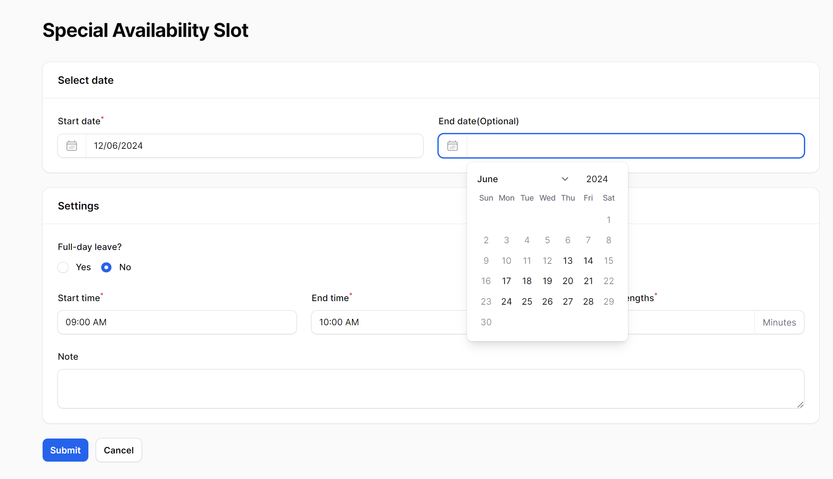

In special settings, the end date is optional. If an "end date" is provided, it indicates a continuous period of time. If not provided, it indicates only a single day.

Rules for special settings: Cannot be made before today.

The logical priority of these settings is: Full-day leave > Temporary adjustments to partial periods > General settings.

1.2 Associated processing
If consultations have already been booked by customers on the days of the special settings, these appointments will be automatically canceled.

2. Booking consultations
Customers can book appointments based on the time slots set by doctors.
2.1 Booking conditions
- Appointments can only be made for dates not later than today, and by default, appointments can only be made up to 14 days in advance (the number of days in advance can be set in the .env file as "ADVANCE_BOOKING_DAYS=14"). And weekend can't be booked.
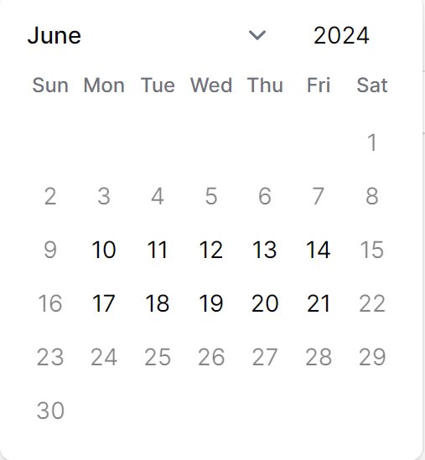

- If a customer booked a consultation for a specific day, another appointment cannot be made for the same customer at the same day (currently, even if there are multiple doctors available on the same day, only one appointment can be made per day. Do you think it's necessary to differentiate appointments based on doctors?).

2.2 Booking process
- Select a date.

- Choose from available doctors for that day.

- Select a time slot. Here, the time slots are calculated based on the starting time of availability slots and consultation lengths. For example, if a doctor's availability is set as 9:00-12:00 and the consultation length is 30 minutes, the time slots will be divided into 9:00-9:30, 9:30-10:00, 10:00-10:30, etc.
If a time slot has already been booked, it cannot be selected.
This design is intended to provide customers with an estimated time, distribute them reasonably, and avoid consultations being concentrated at certain times if there are many customers.
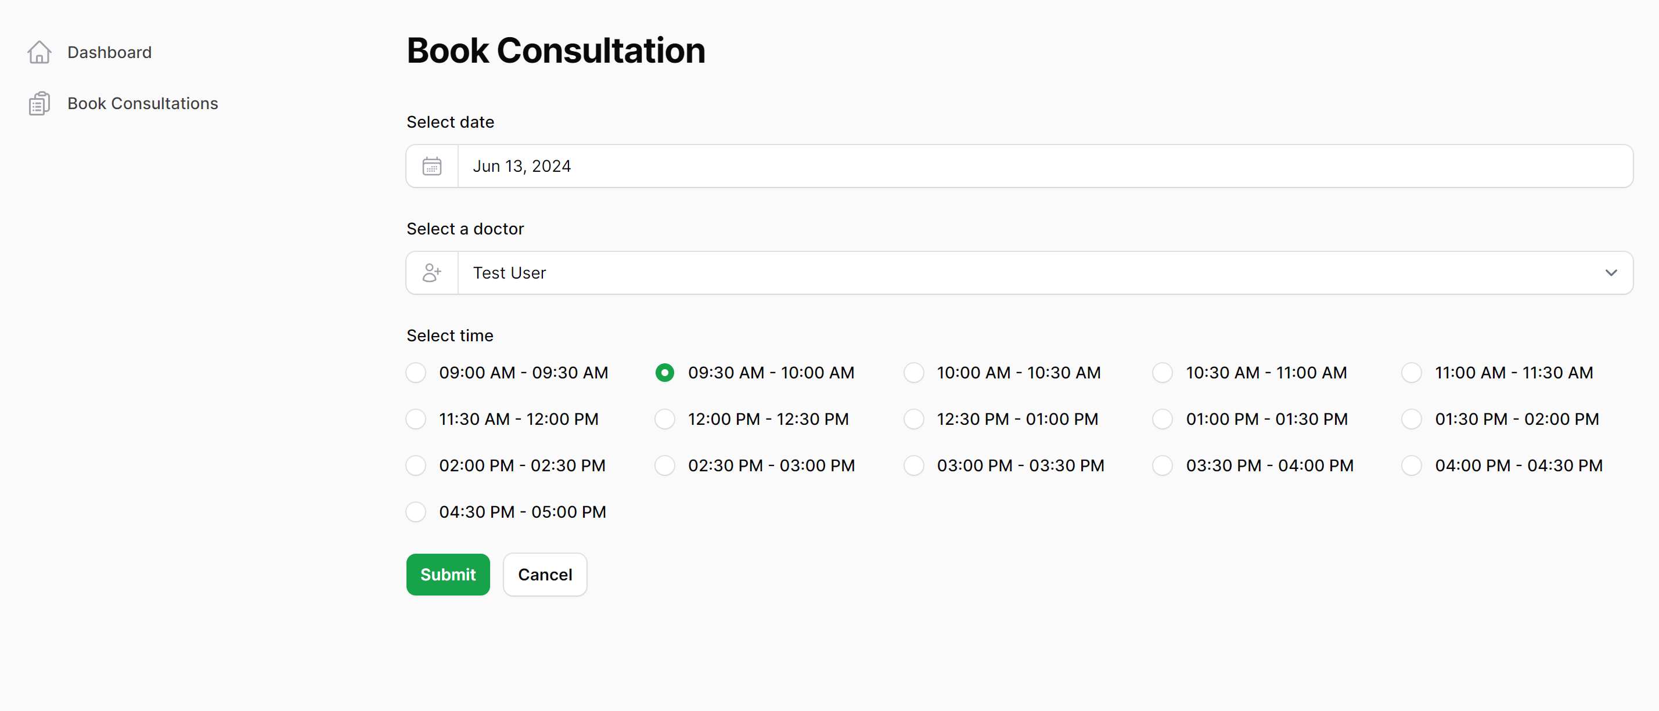

2.3 Viewing and canceling
Customers can view their appointments and cancel them (but only appointments that have not yet expired can be canceled; expired or completed appointments cannot be canceled).
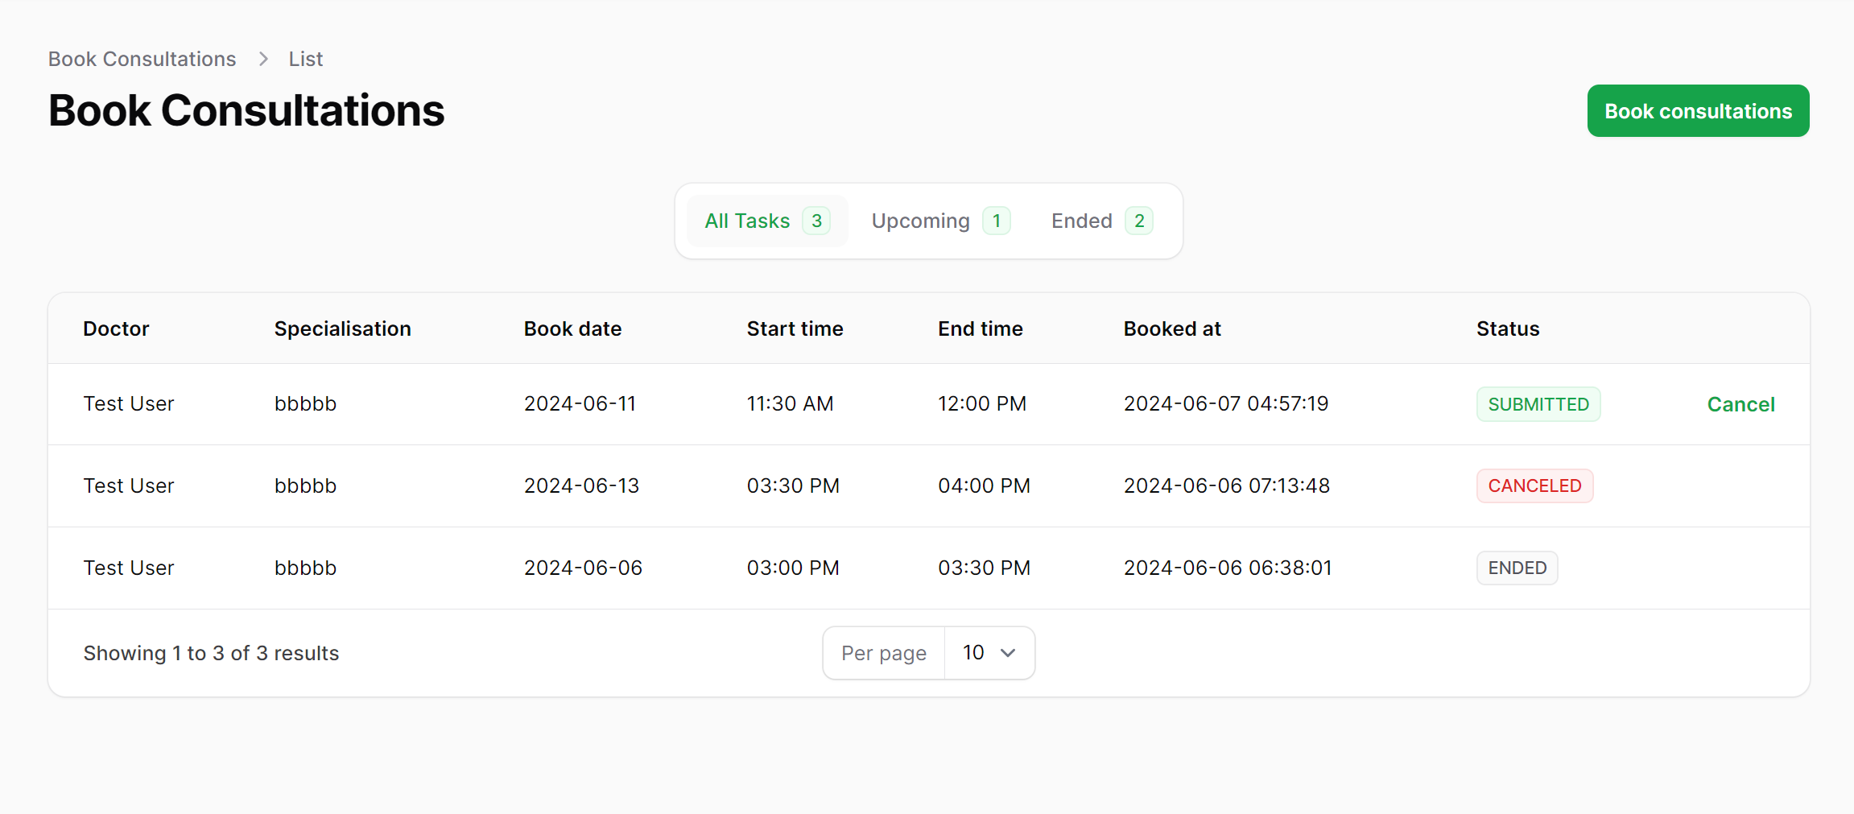
- Notifications
Currently, there is no notification-related functionality. I plan to design the notification sending module after completing all the basic functionality frameworks.

